In this lab, we will run deploy the image we created previously using cloud run

1. At GCP console, search for Cloud Run

1. Go to Deploy container and click Service

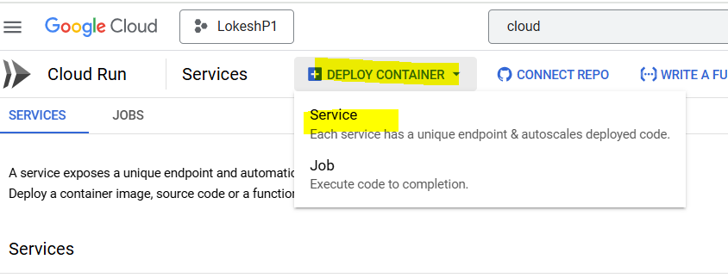

1. Under Deploy from existing image option click select and select the image we created in previous lab under my-repo

1. Give a name, select region and select “Allow unauthenticated invocations option, select request based under billing

1. Make minimum number of instances as 1, ingress for all. Also expand advanced option and explore options there, but do not change anything and click create

1. Click on the URL and this should open the cart page  
   A screenshot of a service

   AI-generated content may be incorrect.

So here, here what we did was, we pushed the image to the Artifact registry and then Cloud Run pulled the image and deployed it to an instance at backend which brings up our application

1. Now on the main page we can see the Revisions and revision name. This is similar to the versions and everytime we push a new version, a new revision will be created  
   A screenshot of a computer

   AI-generated content may be incorrect.
2. Now go to logs and here we can see all logs or details related to this deployment.  
   A screenshot of a computer

   AI-generated content may be incorrect.